**Ansible Controller manage 2 host**

#add the Ip’s of host it could be n number for example purpose we tak 2 only



# edit hosts file by using sudo command and private ip of host note

$sudo –vi hosts



#you can authenticate your host node using private ssh key i.e (.pem) file

1. Need to upload .pem from my computer windows to Ubuntu ec2 instance for that open gitbash

then add this following command

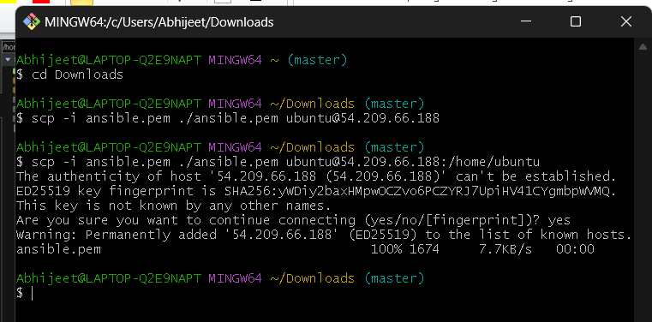

2) change the file path in hosts file



#check weather you able to ping node host using following command

$ ansible –m ping SL

Note: SL is nothing but a group name you can give anything

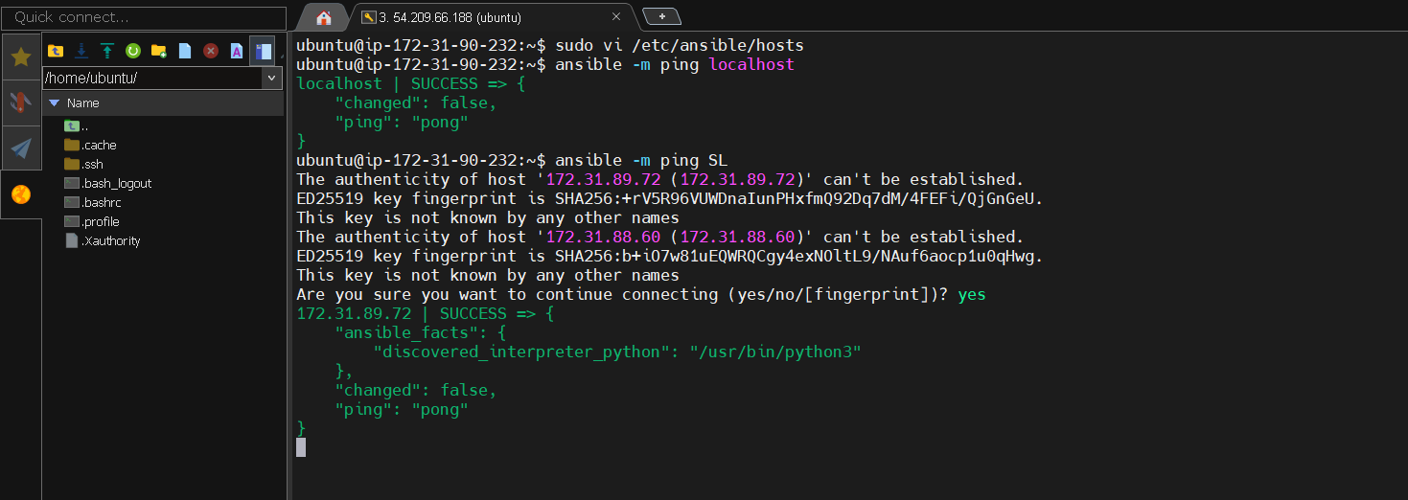

Note : In above example you see there is only showing one ip is given successful you have check for another you have to type ‘yes’ keyword again

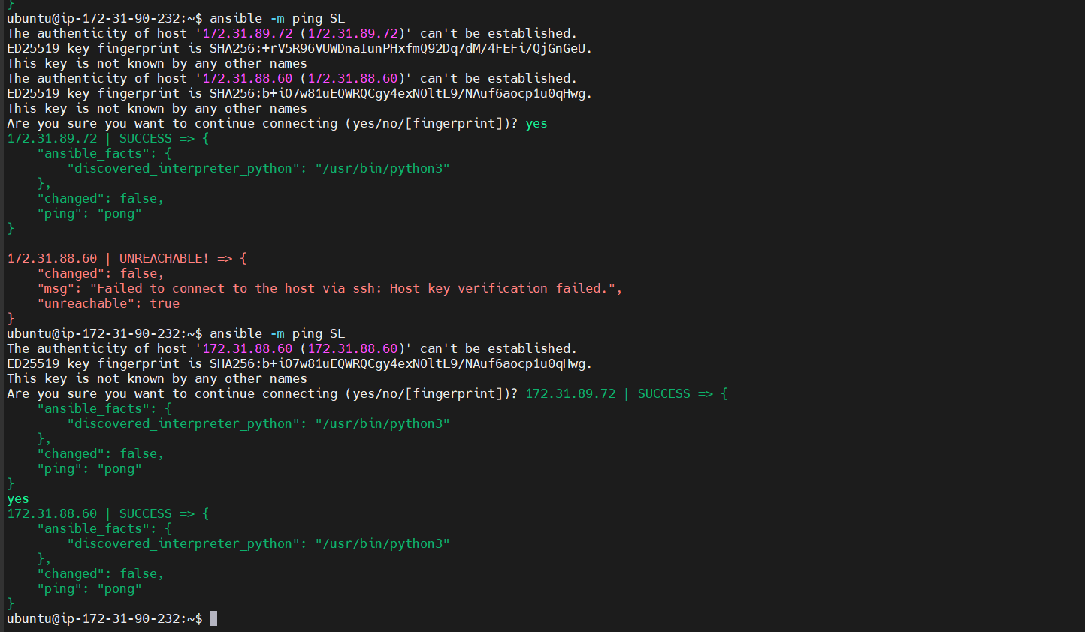

#Now if you get success for both 2 ips then you can create file on both host ect instance

$ ansible SL –a“touch abhijeet”

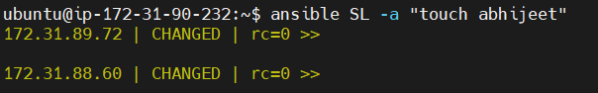

#To verify that Abhijeet file is created or not login to ec2 instace weather file created or not



As you can see in above Abhijeet file is created